EMBEDDED DRIVER GUIDE
ADS1115 I2C One-Shot ADC Driver
Finalized C/H Implementation, ADC Architecture, SAR vs Delta-Sigma, Register Flow, Testing, and Engineering Review
Document authority: Every function name, macro, register value, call sequence, and code excerpt is taken from the five attached finalized source/header files. Theory is used only to explain the hardware behavior implemented by that code.

Coverage | Included
Final source | ads1115.c, ads1115.h, i2c.c, i2c.h, and main.c
Implemented mode | AIN0 single-ended, +/-4.096 V, 128 SPS, one-shot polling, comparator disabled
Register access | 7-bit address 0x48; 16-bit MSB-first register writes and reads
ADC concepts | SAR and delta-sigma pipelines, oversampling, data rate, PGA/FSR/LSB, signed output
Validation | UART basic test plus repeated AIN0 raw/voltage output every 500 ms
Engineering review | Header interface gaps, unbounded polling, unused timeout macro, and fixed scaling

1. Document Control and Source Scope
Control item | Value
Document type | Source-verified embedded ADC driver learning reference
Project root | D:\Embedded Communication Protocols\I2C_ADC_ADS1115_Init
Implementation authority | Only the five attached C/H files listed below
Theory authority | TI ADS111x datasheet SBAS444E and established ADC fundamentals
Design preset | compact_reference_guide with editorial cover
Generated | 10 July 2026
Footer | Embedded Learning Document

2. Finalized Files Read
File | Role | SHA256 prefix
ads1115.c | Device register access, one-shot conversion, scaling, and UART tests | 0c09574b50b8db0b...
i2c.c | STM32F4 I2C1 GPIO, 100 kHz timing, write, and write-read backend | 12116366d7dd2f2a...
main.c | System clock, initialization order, ADS1115 startup test, and 500 ms loop | ace7f20e8f10425d...
ads1115.h | ADS1115 address/register/config macros and public declarations | 5fcbfd85bb06f2c6...
i2c.h | I2C timeout macro and generic I2C1 public declarations | d779de638d9b500b...

3. Learning Objectives
- Trace one AIN0 measurement from main.c through the ADS1115 layer and I2C1 peripheral registers.
- Explain exactly how the implemented 0xC383 configuration selects channel, PGA, mode, and data rate.
- Understand why ADS1115 returns a signed 16-bit value and why the source uses int16_t.
- Compare SAR and delta-sigma ADC operation at the internal-block and timing levels.
- Understand the two-byte STM32F4 receive sequence used by ADS1115 register reads.
- Separate implemented behavior from engineering improvements that are not yet in the finalized code.

4. Project Objective and Problem Statement
The finalized project initializes a shared STM32F4 I2C1 bus, verifies ADS1115 communication by reading the Config and Conversion registers, starts an AIN0 single-shot conversion, polls the OS bit until completion, reads the signed raw value, converts it to volts using the fixed +/-4.096 V LSB, and reports the result over USART2 every 500 ms.
Core engineering problem: The driver must coordinate three different models correctly: STM32F4 event-driven I2C flag sequencing, ADS1115 register/pointer transactions, and delta-sigma conversion timing. A mistake in any one layer can produce a NACK, stale conversion, byte-order error, sign error, or incorrect voltage.

5. System Overview
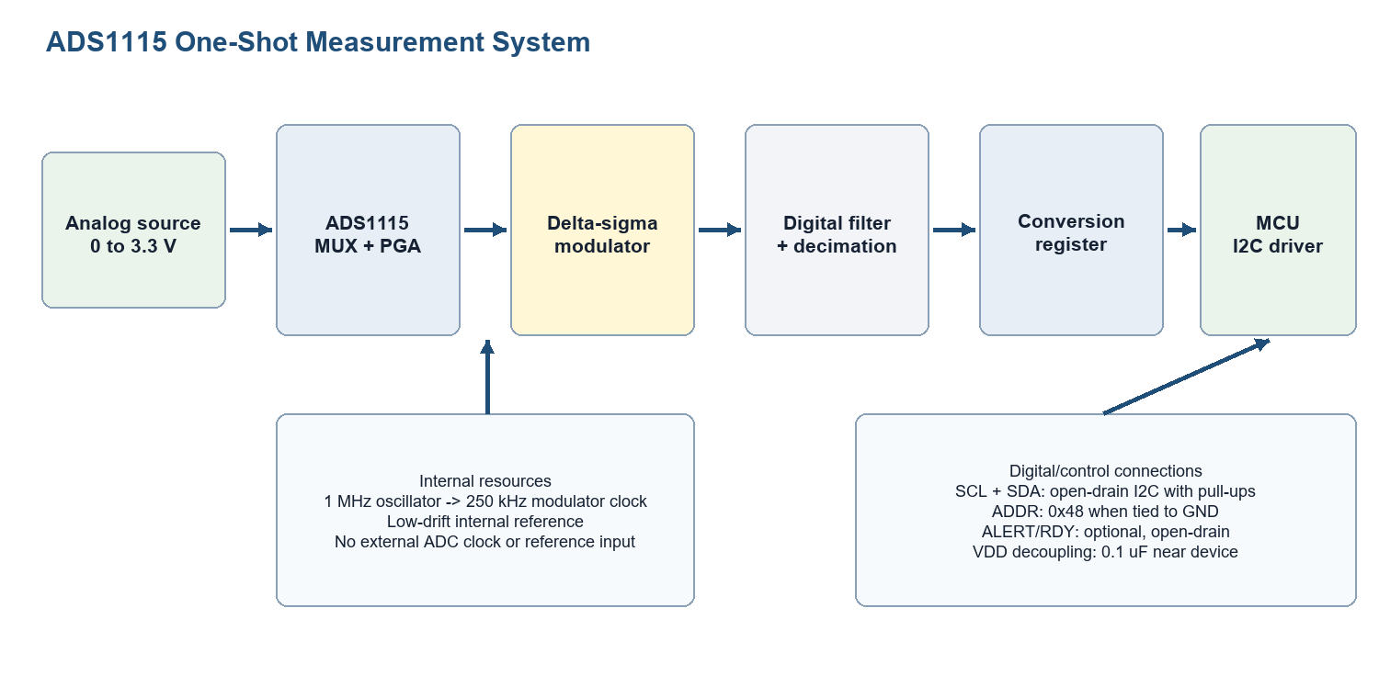
Figure 1. ADS1115 signal path and I2C system context.

5.1 Source-Derived Hardware and Timing Configuration
Item | Final source value | Meaning
MCU peripheral | I2C1 | Generic polling backend used by EEPROM and ADS1115
I2C pins | PB6 SCL, PB7 SDA | GPIOB alternate function 4, open-drain
Pull configuration | Internal pull-up enabled | Source comments prefer external pull-ups
PCLK1 assumption | 32 MHz | Programmed into CR2.FREQ
I2C bus speed | 100 kHz | CCR = 160, TRISE = 33
ADS1115 address | 0x48U | ADDR connected to GND
Config | 0xC383U | AIN0 single-ended, +/-4.096 V, 128 SPS, one-shot
Application period | HAL_Delay(500) | One test request approximately every 500 ms

5.2 Firmware Layering
Layer | Attached file | Responsibility
Application | main.c | Initialize I2C, run basic test, call AIN0 test periodically
Device driver | ads1115.c/.h | Config selection, register framing, conversion state, scaling, UART test
Bus driver | i2c.c/.h | GPIO, I2C timing, START/STOP, address, ACK/NACK, byte movement
Hardware | STM32F4 I2C1 + ADS1115 | Electrical bus signaling and analog conversion

6. SAR ADC Versus Delta-Sigma ADC
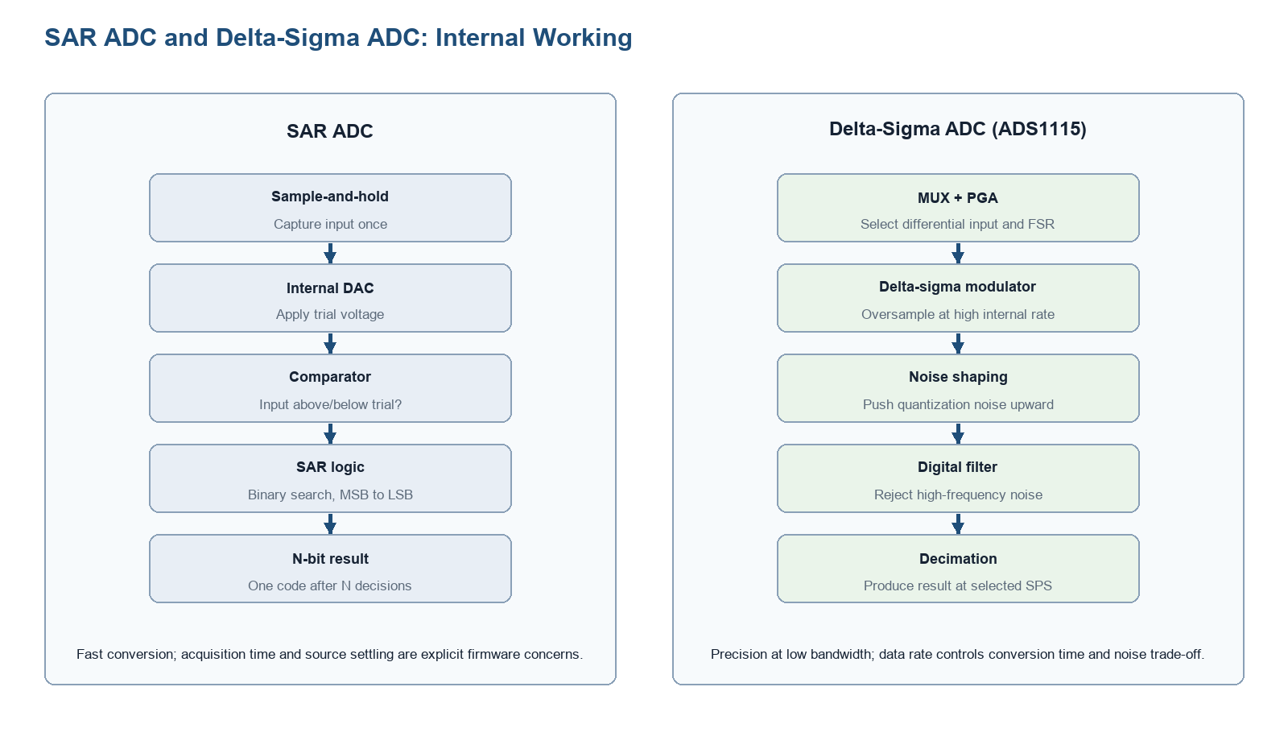
Figure 2. Internal conversion pipelines of SAR and delta-sigma ADCs.

6.1 SAR ADC Working Sequence
- A sample-and-hold capacitor captures the input voltage during the acquisition window.
- The successive-approximation register first tries the most-significant bit.
- An internal DAC converts the trial code back into an analog voltage.
- A comparator decides whether the held input is above or below the DAC trial.
- The SAR logic keeps or clears that bit and repeats toward the least-significant bit.
- After approximately N decisions, an N-bit conversion result is available.

6.2 Delta-Sigma Working Sequence
- The MUX selects AINP and AINN; the PGA defines differential full-scale scaling.
- A switched-capacitor modulator samples the input at a much higher rate than the final SPS.
- Feedback inside the modulator produces a high-rate bitstream whose density represents the input.
- Quantization noise is shaped toward higher frequencies.
- A digital filter removes much of that high-frequency noise.
- Decimation reduces the filtered stream to the selected 8-860 SPS output rate.
- The completed signed 16-bit code is stored in the Conversion register.

6.3 Practical Difference for Firmware
Concern | SAR ADC | ADS1115 delta-sigma
Conversion trigger | Start regular/injected conversion | Write OS=1 while in single-shot power-down
Timing configuration | ADC clock and acquisition cycles | Select DR[2:0]; internal clock/filter handle conversion
Result latency | Acquisition plus bit decisions | Approximately wake-up plus one output-rate cycle
Noise control | Source settling and optional averaging | Intrinsic oversampling/filtering; lower DR generally improves noise
Throughput | Usually high | Maximum 860 SPS
Input usage | Often single-ended unsigned | Differential core and signed two's-complement output
Best fit | Fast multiplexed control signals | Precision low-bandwidth sensor measurement

Key mental model: A SAR ADC asks a sequence of yes/no comparison questions about one held sample. A delta-sigma ADC measures continuously at a high internal rate and calculates one precise low-rate result through feedback, noise shaping, filtering, and decimation.

7. ADS1115 Internal Functionality
Block | Function | Connection to finalized code
MUX | Selects differential or single-ended input pair | 0xC383 uses MUX=100 for AIN0 to GND
PGA | Selects full-scale range | 0xC383 uses PGA=001 for +/-4.096 V
Delta-sigma core | Oversamples and shapes quantization noise | Runs internally after OS start
Digital filter | Filters and decimates modulator data | DR=100 selects 128 SPS result rate
Conversion register | Holds latest signed result | ADS1115_ReadRaw() reads pointer 0x00
Config register | Controls and reports conversion | Start uses pointer 0x01; ready test checks bit 15

7.1 Oversampling, Data Rate, and Conversion Time
The ADS1115 internally samples much faster than its final output rate. Lowering the selected data rate increases the effective oversampling ratio and generally improves input-referred noise. The finalized driver selects 128 SPS, giving a nominal conversion cycle of 7.8125 ms; its source comment rounds this to about 7.8 ms.
Data-rate setting | Nominal conversion time | Trade-off
8 SPS | 125 ms | Highest internal averaging, slowest updates
128 SPS (implemented) | 7.8125 ms | Balanced learning configuration
860 SPS | About 1.163 ms | Fastest updates, typically more noise

8. PGA, FSR, LSB, and Signed Scaling
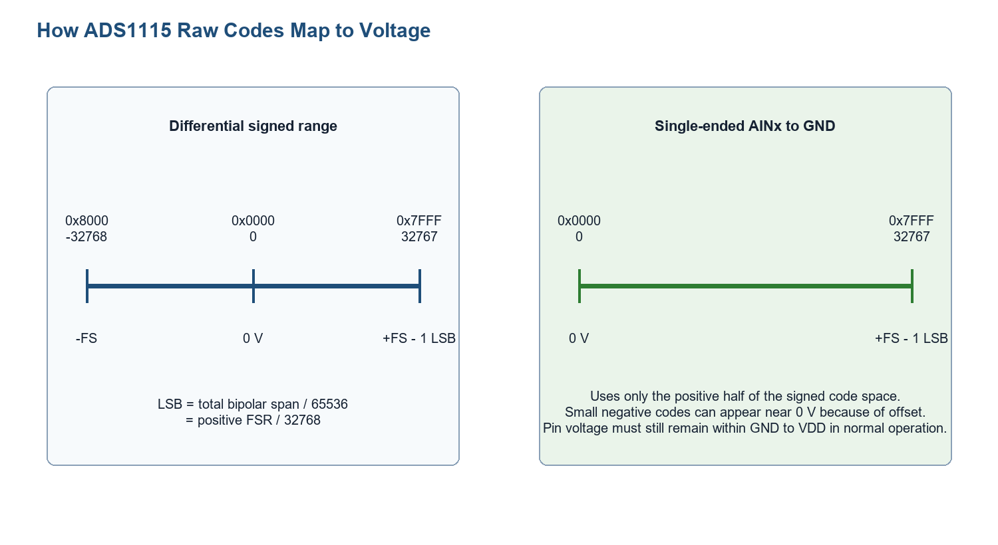
Figure 3. Signed ADS1115 code space and single-ended usage.
Selected source setting | Value | Calculation consequence
PGA bits | 001 | Full-scale range is +/-4.096 V
Positive FSR | 4.096 V | Use 4.096 / 32768
LSB | 0.000125 V | 125 microvolts per code
Raw type | int16_t | Preserves signed two's-complement meaning
Implemented formula | raw * 0.000125f | Valid only while PGA remains +/-4.096 V

return ((float)raw * 0.000125f);
Source fidelity: The scaling line above is copied exactly from ads1115.c. The driver does not yet accept PGA as a parameter, so changing the Config PGA bits without changing this constant would produce an incorrect voltage.

9. I2C Address and ADS1115 Register Model
Item | Final source macro | Role
7-bit address | ADS1115_ADDR_GND 0x48U | Used by both read and write APIs
Conversion | ADS1115_REG_CONVERSION 0x00U | Signed ADC result
Config | ADS1115_REG_CONFIG 0x01U | MUX/PGA/mode/data rate/status
Low threshold | ADS1115_REG_LO_THRESH 0x02U | Declared; not used by current polling flow
High threshold | ADS1115_REG_HI_THRESH 0x03U | Declared; not used by current polling flow
Reset Config | ADS1115_CONFIG_RESET_VALUE 0x8583U | Basic communication/reset-state check
AIN0 one-shot | ADS1115_CONFIG_AIN0_SINGLE_4V096_128SPS 0xC383U | Implemented measurement configuration

9.1 Decode of 0xC383
Bits | Field | Value | Implemented meaning
15 | OS | 1 | Start one conversion when idle
14:12 | MUX | 100 | AIN0 relative to GND
11:9 | PGA | 001 | +/-4.096 V FSR
8 | MODE | 1 | Single-shot / power-down
7:5 | DR | 100 | 128 SPS
4:2 | Comparator controls | 000 | Default mode/polarity/latch
1:0 | COMP_QUE | 11 | Comparator disabled

9.2 Register Transaction Frames
Operation | Implemented generic I2C call | Bus meaning
Write register | I2C1_MasterWrite(dev_addr, tx_data, 3U) | Pointer, MSB, LSB
Read register | I2C1_MasterWriteRead(dev_addr, &reg_addr, 1U, rx_data, 2U) | Pointer write, repeated START, two-byte read
Reassembly | ((uint16_t)rx_data[0] << 8) | rx_data[1] | ADS1115 sends MSB first

10. Finalized ADS1115 Module Implementation
Implemented API | Role | Called by
ADS1115_Init | Verify Config-register communication and report reset-value match | main.c and ADS1115_TestBasic
ADS1115_WriteRegister | Send pointer, MSB, and LSB | ADS1115_StartSingleShot_AIN0
ADS1115_ReadRegister | Write pointer and read two-byte register | Init, tests, ready check, raw read
ADS1115_StartSingleShot_AIN0 | Write 0xC383 | ADS1115_ReadSingleEnded_AIN0
ADS1115_IsConversionReady | Read Config and test bit 15 | ADS1115_ReadSingleEnded_AIN0
ADS1115_ReadRaw | Read Conversion and cast to int16_t | ADS1115_ReadSingleEnded_AIN0
ADS1115_RawToVoltage | Multiply raw by 0.000125f | ADS1115_ReadSingleEnded_AIN0
ADS1115_Test_AIN0 | Print raw and voltage through USART2 | main.c loop

10.1 Communication Initialization
uint8_t ADS1115_Init(void)
{
uint16_t config_value;
/*
* After power-up, ADS1115 should respond on I2C.
* Read Config register to verify communication.
*/
if(ADS1115_ReadRegister(ADS1115_ADDR_GND,
ADS1115_REG_CONFIG,
&config_value) != E_OK)
{
return E_NOT_OK;
}
/*
* Optional: verify reset/default value.
*
* The default Config register value is 0x8583.
* But do not make init fail only because of mismatch yet,
* because if code previously configured the ADC and power was
* not cycled, the value may be different.
*/
if(config_value == ADS1115_CONFIG_RESET_VALUE)
{
USART2_SendString("ADS1115 Init OK: default config detected\r\n");
}
else
{
USART2_SendString("ADS1115 Init OK: config differs from reset value\r\n");
}
/*
* For first driver stage, we only confirm communication.
* Later, we will write our preferred default config here.
*/
return E_OK;
}
The function treats a successful Config read as initialization success. It reports whether the readback equals the reset value but deliberately does not fail solely on a mismatch.

10.2 Exact Register Write Function
uint8_t ADS1115_WriteRegister(uint8_t dev_addr,
uint8_t reg_addr,
uint16_t reg_data)
{
uint8_t tx_data[3];
/*
* ADS1115 register write frame:
*
* START
* device address + W
* register pointer
* register MSB
* register LSB
* STOP
*/
tx_data[0] = reg_addr;
tx_data[1] = (uint8_t)((reg_data >> 8) & 0xFFU);
tx_data[2] = (uint8_t)(reg_data & 0xFFU);
if(I2C1_MasterWrite(dev_addr, tx_data, 3U) != E_OK)
{
USART2_SendString("ADS1115 Write Failed...\r\n");
return E_NOT_OK;
}
return E_OK;
}

10.3 Exact Register Read Function
uint8_t ADS1115_ReadRegister(uint8_t dev_addr,
uint8_t reg_addr,
uint16_t *reg_data)
{
uint8_t rx_data[2];
if(reg_data == NULL)
{
return E_NOT_OK;
}
/*
* ADS1115 register read frame:
*
* Write phase:
* register pointer
*
* Read phase:
* register MSB
* register LSB
*/
if(I2C1_MasterWriteRead(dev_addr,
&reg_addr,
1U,
rx_data,
2U) != E_OK)
{
USART2_SendString("ADS1115 Read Failed...\r\n");
return E_NOT_OK;
}
/*
* ADS1115 sends MSB first, then LSB.
*/
*reg_data = ((uint16_t)rx_data[0] << 8) | rx_data[1];
return E_OK;
}

10.4 One-Shot Start and Ready Test
uint8_t ADS1115_StartSingleShot_AIN0(void)
{
return ADS1115_WriteRegister(ADS1115_ADDR_GND,
ADS1115_REG_CONFIG,
ADS1115_CONFIG_AIN0_SINGLE_4V096_128SPS);
}
uint8_t ADS1115_IsConversionReady(uint8_t *ready)
{
uint16_t config;
if(ready == NULL)
{
return E_NOT_OK;
}
if(ADS1115_ReadRegister(ADS1115_ADDR_GND,
ADS1115_REG_CONFIG,
&config) != E_OK)
{
return E_NOT_OK;
}
if(config & 0x8000U)
{
*ready = 1U;
}
else
{
*ready = 0U;
}
return E_OK;
}

10.5 Raw Read and Complete Measurement
uint8_t ADS1115_ReadRaw(int16_t *raw)
{
uint16_t reg_value;
if(raw == NULL)
{
return E_NOT_OK;
}
if(ADS1115_ReadRegister(ADS1115_ADDR_GND,
ADS1115_REG_CONVERSION,
&reg_value) != E_OK)
{
return E_NOT_OK;
}
*raw = (int16_t)reg_value;
return E_OK;
}
uint8_t ADS1115_ReadSingleEnded_AIN0(int16_t *raw, float *voltage)
{
uint8_t ready = 0U;
if((raw == NULL) || (voltage == NULL))
{
return E_NOT_OK;
}
if(ADS1115_StartSingleShot_AIN0() != E_OK)
{
return E_NOT_OK;
}
/*
* At 128 SPS, conversion time is about 7.8 ms.
* We poll OS bit here.
*/
do
{
if(ADS1115_IsConversionReady(&ready) != E_OK)
{
return E_NOT_OK;
}
} while(ready == 0U);
if(ADS1115_ReadRaw(raw) != E_OK)
{
return E_NOT_OK;
}
*voltage = ADS1115_RawToVoltage(*raw);
return E_OK;
}

10.6 UART Measurement Test
void ADS1115_Test_AIN0(void)
{
int16_t raw;
float voltage;
char msg[100];
if(ADS1115_ReadSingleEnded_AIN0(&raw, &voltage) == E_OK)
{
sprintf(msg, "AIN0 Raw = %d, Voltage = %.4f V\r\n", raw, voltage);
USART2_SendString(msg);
}
else
{
USART2_SendString("ADS1115 AIN0 Read Failed\r\n");
}
}

11. Finalized I2C Backend

11.1 GPIO and Timing Summary
Register field | Final source operation | Purpose
GPIOB MODER | PB6/PB7 = alternate function | Route I2C1 signals
GPIOB OTYPER | PB6/PB7 open-drain | Required wired-AND I2C behavior
GPIOB PUPDR | Internal pull-up enabled | Initial bus bias; external preferred
GPIOB AFR[0] | AF4 | I2C1 mapping
I2C1 CR2.FREQ | 32U | APB1 input clock in MHz
I2C1 CCR | 160U | 100 kHz standard-mode timing
I2C1 TRISE | 33U | Standard-mode maximum rise time

I2C1->CR2 &= ~I2C_CR2_FREQ;
I2C1->CR2 |= 32U;
I2C1->CCR = 160U;
I2C1->TRISE = 33U;

11.2 Mandatory ADDR-Clear Sequence
static void I2C1_ClearADDR(void)
{
volatile uint32_t dummy;
dummy = I2C1->SR1;
dummy = I2C1->SR2;
(void)dummy;
}

11.3 Two-Byte Receive Path Used by ADS1115
else if(rx_len == 2U)
{
/*
* For 2-byte read:
* Set POS before clearing ADDR.
* Disable ACK before clearing ADDR.
*/
I2C1->CR1 |= I2C_CR1_POS;
I2C1->CR1 &= ~I2C_CR1_ACK;
/*
* Clear ADDR.
*/
I2C1_ClearADDR();
/*
* Wait until both bytes are received.
* BTF = 1 means two bytes are ready:
* one in DR, one in shift register.
*/
while(!(I2C1->SR1 & I2C_SR1_BTF));
/*
* Generate STOP before reading the two bytes.
*/
I2C1->CR1 |= I2C_CR1_STOP;
/*
* Read first byte.
*/
rx_data[0] = (uint8_t)I2C1->DR;
/*
* Read second byte.
*/
rx_data[1] = (uint8_t)I2C1->DR;
/*
* Restore ACK and POS for future operations.
*/
I2C1->CR1 &= ~I2C_CR1_POS;
I2C1->CR1 |= I2C_CR1_ACK;
}
This is the active receive branch for every ADS1115 register read. POS is set and ACK is cleared before ADDR is cleared, BTF waits for both bytes, STOP is generated, then DR is read twice before POS/ACK are restored.

12. Finalized main.c Integration
//I2C --> EEPROM
I2C1_GPIO_Init();
I2C1_Init_100kHz();
USART2_SendString("I2C1 Initialized for AT24C256...!!!!!\r\n");
//Test EEPROM
AT24C256_TestAllApis();
//Test ADC
ADS1115_Init();
ADS1115_TestBasic();
while (1)
{
ADS1115_Test_AIN0();
HAL_Delay(500);
The ADS1115 shares the already initialized I2C1 bus with the AT24C256. The startup path calls ADS1115_Init() and then ADS1115_TestBasic(); the endless loop calls ADS1115_Test_AIN0() and waits 500 ms.

13. Implemented One-Shot Algorithm
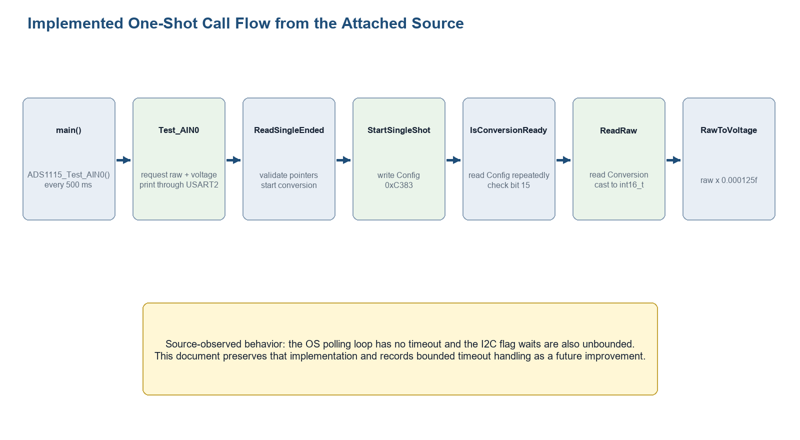
Figure 4. Exact call flow represented by the finalized source.
- main() calls ADS1115_Test_AIN0().
- ADS1115_ReadSingleEnded_AIN0() validates the raw and voltage pointers.
- ADS1115_StartSingleShot_AIN0() writes 0xC383 to the Config register.
- ADS1115_IsConversionReady() repeatedly reads Config and checks mask 0x8000U.
- When ready, ADS1115_ReadRaw() reads the Conversion register and casts uint16_t to int16_t.
- ADS1115_RawToVoltage() multiplies the signed code by 0.000125f.
- ADS1115_Test_AIN0() formats and transmits raw and voltage values over USART2.
- main() waits 500 ms before the next measurement request.

14. Testing and Expected Results

14.1 Basic Register Test
void ADS1115_TestBasic(void)
{
uint16_t config;
uint16_t conversion;
char msg[100];
if(ADS1115_Init() != E_OK)
{
USART2_SendString("ADS1115 Basic Test Failed: Init error\r\n");
return;
}
if(ADS1115_ReadRegister(ADS1115_ADDR_GND,
ADS1115_REG_CONFIG,
&config) == E_OK)
{
sprintf(msg, "ADS1115 Config Register = 0x%04X\r\n", config);
USART2_SendString(msg);
}
else
{
USART2_SendString("ADS1115 Config Register Read Failed\r\n");
}
if(ADS1115_ReadRegister(ADS1115_ADDR_GND,
ADS1115_REG_CONVERSION,
&conversion) == E_OK)
{
sprintf(msg, "ADS1115 Conversion Register = 0x%04X\r\n", conversion);
USART2_SendString(msg);
}
else
{
USART2_SendString("ADS1115 Conversion Register Read Failed\r\n");
}
}
Output | Expected interpretation
ADS1115 Init OK: default config detected | Config read succeeded and equals 0x8583
ADS1115 Init OK: config differs from reset value | I2C read succeeded; device has a non-reset configuration
ADS1115 Config Register = 0x.... | Confirms 16-bit Config byte order and register pointer access
ADS1115 Conversion Register = 0x.... | Reads latest conversion word; 0x0000 is normal before first conversion

14.2 AIN0 Measurement Test
Input checkpoint | Ideal raw at 125 uV/LSB | Expected voltage output
0 V | Approximately 0 | Near 0.0000 V; small offset codes are possible
0.5 V | 4000 | Approximately 0.5000 V
1.0 V | 8000 | Approximately 1.0000 V
2.048 V | 16384 | Approximately 2.0480 V
3.3 V | 26400 | Approximately 3.3000 V if VDD and input permit

14.3 Logic Analyzer Checkpoints
- Address byte corresponds to 7-bit 0x48 with the proper R/W bit.
- Config write transfers pointer 0x01 followed by bytes 0xC3 and 0x83.
- Config polling writes pointer 0x01 and reads two bytes MSB first.
- Conversion read writes pointer 0x00 and reads two bytes.
- The controller terminates the second receive byte with NACK/STOP through the STM32F4 two-byte sequence.

15. Engineering Review of the Finalized Source

15.1 Confirmed Strengths
- Device-specific ADS1115 logic is cleanly separated from the generic I2C1 backend.
- Register writes correctly send pointer, MSB, then LSB.
- Register reads correctly use a pointer write followed by a repeated-START two-byte read.
- The raw result is converted to int16_t before voltage scaling.
- 0xC383 matches the documented AIN0, +/-4.096 V, 128 SPS, one-shot configuration.
- Init correctly distinguishes communication success from reset-value equality.
- The I2C two-byte receive sequence handles STM32F4 POS/ACK/BTF/STOP ordering.

15.2 Source-Observed Issues and Risks
Finding | Evidence in attached source | Impact / recommendation
Missing ADS1115 include in main.c | main.c calls ADS1115 APIs but does not include ads1115.h | Add the header explicitly; do not rely on implicit declarations
Missing public prototypes | ads1115.h omits ADS1115_Test_AIN0() and ADS1115_ReadSingleEnded_AIN0() | Declare externally used APIs; make internal-only functions static
Unbounded OS polling | do/while continues until ready != 0 | A device/bus fault can block forever; add a conversion deadline
Unbounded I2C flag waits | BUSY, SB, ADDR, TXE, BTF, RXNE loops have no timeout | I2C_TIMEOUT is defined but unused; integrate it consistently
Fixed PGA scaling | ADS1115_RawToVoltage uses 0.000125f | Correct for current 0xC383 only; bind scaling to selected PGA before generalizing
Limited I2C errors | AF is checked in selected waits | Add BERR, ARLO, OVR, timeout, and bus recovery handling
Header dependency | i2c.h uses uint8_t/uint16_t without including stdint.h | Make the header self-contained
Duplicate initialization call | main calls ADS1115_Init(), then TestBasic() calls Init again | Harmless but redundant; simplify when the test flow is finalized

Important distinction: These findings are documented review observations. The source files were not modified, and the document does not present proposed timeout APIs or generalized code as if they already exist.

16. Debugging Guide
Symptom | Likely source-level cause | Check
Build warning/error at ADS1115_Test_AIN0 | Missing ads1115.h include/prototype | Include header and expose the called API
No ACK | Address convention, pull-ups, ADDR wiring, power | Verify 0x48 as 7-bit address and observe bus
Config read wrong byte order | MSB/LSB assembly problem | Expect rx_data[0] as MSB
Voltage wrong by fixed ratio | Config PGA differs from fixed 0.000125f | Decode PGA bits and use matching LSB
Application hangs | Unbounded I2C or OS loop | Inspect BUSY/SB/ADDR/BTF/RXNE and add timeouts
Noisy readings | Data rate, source impedance, wiring, grounding | Try lower DR and verify analog source/decoupling
Negative raw near 0 V | ADS1115 offset with signed format | Treat small negative code as possible offset, not byte-order failure

17. Current Limitations
- Only AIN0 single-ended input is implemented.
- PGA and data rate are fixed through one Config constant.
- Conversion completion uses blocking polling.
- Comparator and ALERT/RDY conversion-ready features are not used.
- There is no timeout or recovery path for a stuck I2C bus or conversion.
- Voltage conversion uses floating point and a fixed LSB.

18. Future Improvements
- Correct the public header/interface gaps found in the attached source.
- Apply I2C_TIMEOUT to all hardware-flag waits and add explicit error returns.
- Add a bounded OS polling timeout derived from the selected data rate.
- Generalize MUX, PGA, and DR configuration while keeping scaling synchronized.
- Add integer microvolt conversion for systems that avoid floating point.
- Add differential channel support and polarity validation.
- Use ALERT/RDY for interrupt-driven conversion completion.
- Add calibration and multi-sample statistical tests across data rates.

19. Conclusion
The finalized driver correctly demonstrates the essential ADS1115 one-shot path: configure AIN0, start one delta-sigma conversion, poll operational status, read a signed 16-bit result, and apply the LSB selected by the PGA. The source is a strong learning implementation because it exposes both the ADS1115 register model and the STM32F4 two-byte I2C receive sequence. Its next maturity step is bounded failure handling and a self-consistent public interface, not a change to the underlying conversion model.

Appendix A. Source-Derived Quick Reference
Item | Final source value
Address | 0x48U
Config reset | 0x8583U
One-shot AIN0 Config | 0xC383U
Conversion register | 0x00U
Config register | 0x01U
Ready mask | 0x8000U in ads1115.c
LSB | 0.000125f V/code
I2C speed | 100 kHz
PCLK1 programming | 32 MHz
Measurement delay | 500 ms

Appendix B. Full Source Hashes
File | SHA256
ads1115.c | 0c09574b50b8db0bf3c1acd20d50b76bdf935e4340d99b661f3f1ddb35564ba0
i2c.c | 12116366d7dd2f2a673c3e4ef12be044023d90376f85c6a45fc883bd8314ec79
main.c | ace7f20e8f10425dd5dbe9b7a670206b775d5d62890094b148f08e64eff9103c
ads1115.h | 5fcbfd85bb06f2c6c54f595c3229cedb3f96057eed396e2b2708ae725342c629
i2c.h | d779de638d9b500b62e14c5c11715621cf65f00db9761d72903c156e5d157f24

Appendix C. Revision Checklist
- Add #include "ads1115.h" to the application module that calls ADS1115 APIs.
- Declare ADS1115_Test_AIN0() in ads1115.h; decide whether ADS1115_ReadSingleEnded_AIN0() is public.
- Make i2c.h self-contained with the required integer type include.
- Implement I2C_TIMEOUT in all polling loops.
- Add a conversion-ready timeout to ADS1115_ReadSingleEnded_AIN0().
- Keep the voltage LSB synchronized with PGA whenever configuration becomes selectable.
- Capture and archive a logic-analyzer trace for 0xC383 write, OS polling, and Conversion read.

Appendix D. Theory Reference
Texas Instruments ADS1113/ADS1114/ADS1115 datasheet, SBAS444E, was used for ADC architecture, register-field meaning, data format, electrical behavior, and SAR/delta-sigma context. No chat-generated code is used as implementation authority in this edition.

